**Smart Diagnose Hub**

**(Multi Diseases Prediction App)**

**Bhavya Parekh**

**Sujal Kumar**

**Raghav Soni**

**Kota Anusha**

**Date: 26-06-2024**

**Abstract:**

Smart Diagnosis Hub entails the creation of a comprehensive application for Multidisease prediction, designed to serve both healthcare professionals and individuals seeking proactive health management. The application will leverage advanced machine learning algorithms and extensive medical databases to analyse user inputs and provide predictions for various diseases. Users will have access to personalized health profiles, risk assessments, and recommendations for further medical consultation or preventive measures. The platform will prioritize user privacy and data security while delivering accurate and actionable insights for informed decision making.

1. **Problem Statement**

In the era of digital healthcare advancement, the need for reliable diagnostic tools is paramount. Smart Diagnosis Hub, an innovative project, focuses on developing an application for multi-disease prediction, catering to the evolving landscape of medical diagnostics. With a surge in demand for accessible and accurate health assessment solutions, project aims to revolutionize medical diagnostics through technological innovation and data-driven insights.

1. **Market/Customer Need Assessment**

Smart Diagnose Hub leverages cutting-edge machine learning models to revolutionize healthcare accessibility and diagnosis. Through rigorous market research, we have identified key pain points in traditional healthcare systems, such as limited access and long wait times. Our application targets a diverse audience, ensuring accessibility for all demographics. By gathering user feedback and conducting beta testing, we continuously refine our platform's usability and features. Privacy and security are paramount, as our machine learning algorithms analyse sensitive health data.

Users benefit from personalized recommendations tailored to their unique symptoms and medical history. Educational resources within the app empower individuals with knowledge about various health conditions. Our platform is designed for scalability, capable of handling increased demand and integrating seamlessly with existing healthcare systems. Continuous improvement drives our commitment to staying ahead of evolving customer needs and technological advancements. With Smart Diagnose Hub, we are not just providing a diagnosis; we're revolutionizing healthcare delivery through innovation and machine learning expertise.

The Smart Diagnosis Hub aims to bridge the gap between traditional medical practices and cutting-edge digital technologies, offering users a seamless and intuitive experience in their quest for optimal health outcomes. By harnessing the capabilities of machine learning algorithms and vast medical knowledge databases, the system endeavours to provide accurate disease predictions, personalized treatment recommendations, and invaluable insights into various health conditions.

In a world where access to healthcare services may be limited or hindered by various factors, the Smart Diagnosis Hub seeks to empower individuals with the tools and resources they need to make informed decisions about their health. Through its user-friendly interface, extensive database of diseases and treatments, and interactive features such as symptom analysis and expert consultations, the system aims to democratize access to quality healthcare and improve health outcomes for users worldwide.

1. **Target Specification and characterization**

The Smart Diagnosis Hub project aims to create a versatile and reliable application for multi-disease prediction, with a focus on simplifying health assessment while ensuring accuracy, accessibility, and inclusivity.

* Developing an intuitive and user-friendly application for predicting various diseases, catering to both healthcare professionals and individuals.
* Offering a diverse range of predictive models for diseases prevalent across different demographics and geographical regions.
* Implementing advanced machine learning algorithms and medical data analysis techniques to enhance prediction accuracy and reliability.
* Providing personalized health insights and recommendations based on individual risk profiles and health history.
* Prioritizing accessibility features to ensure that the application is usable by individuals with diverse needs and abilities.
* Facilitating data-driven decision-making in healthcare management and preventive interventions.
* Establishing robust privacy and security measures to safeguard user data and maintain confidentiality.

Customers prioritize privacy and seek convenient, efficient healthcare solutions. They are proactive about their health, eager for personalized recommendations and educational resources. Early adopters of technology, they value innovation and accessibility, particularly those with disabilities or limited mobility. The goal of the Smart Diagnosis Hub project is to empower individuals to proactively manage their health and facilitate more efficient. Continuous engagement is key, fostering a collaborative community to shape the future of healthcare innovation.

1. **External Search (information sources)**

I use the Online Kaggle dataset for this project. Dataset can be found here: <https://www.kaggle.com/datasets>. I have made a project for 3 diseases which includes Diabetes, Heart Disease, Parkinson. By inserting some report values, my ML model will predict if he/she has a disease or not. Data have been pre-processed properly.

**Let’s view our dataset for all the three diseases:**

1. Diabetes:

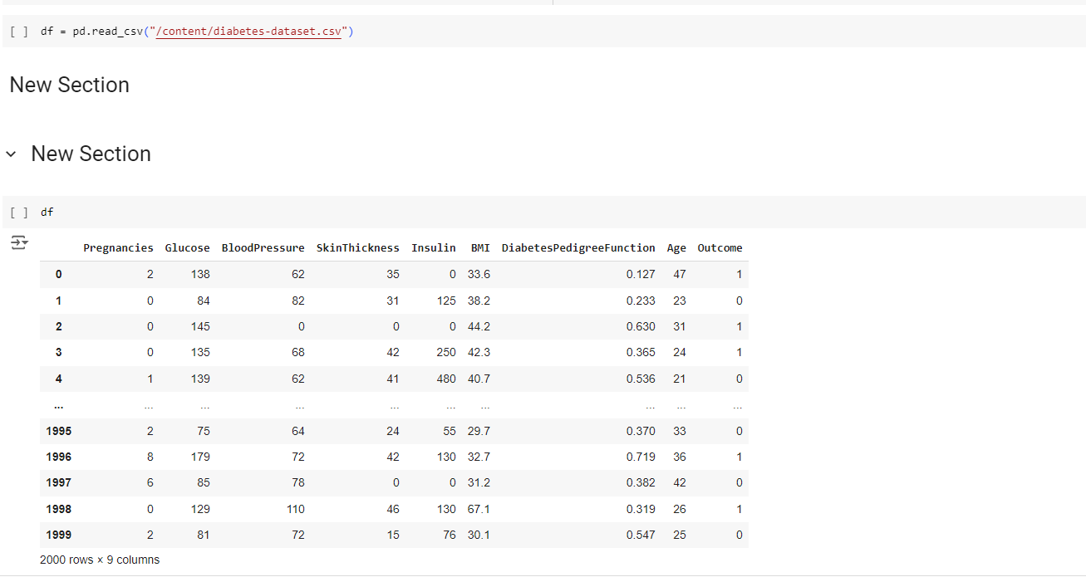

1. Heart Disease:

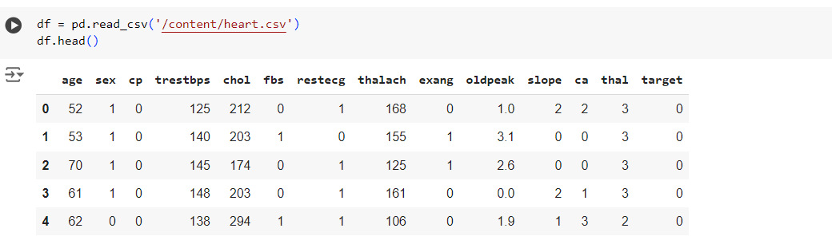

1. Parkinson Disease:

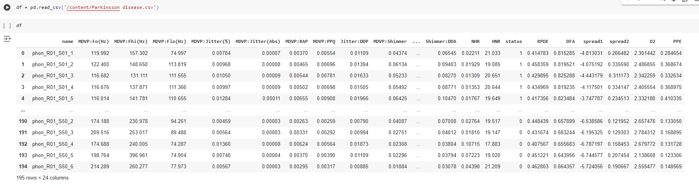

1. **Benchmarking**

Smart Diagnose Hub against existing products and services, we have conducted a comprehensive analysis to highlight its unique features and competitive advantages in the healthcare landscape. Leveraging state-of-the-art machine learning and artificial intelligence technologies, our application offers a sophisticated yet user-friendly platform for disease prediction, diagnosis, and personalized health management.

**Let’s see corelation matrix for all of the three diseases:**

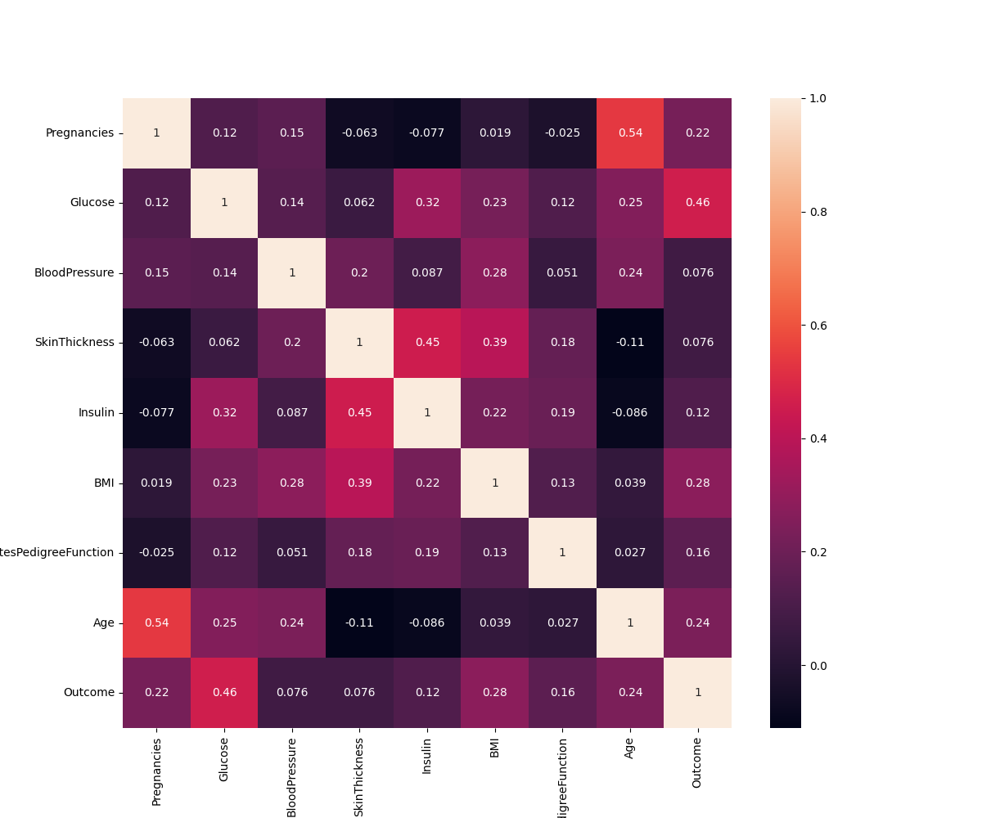

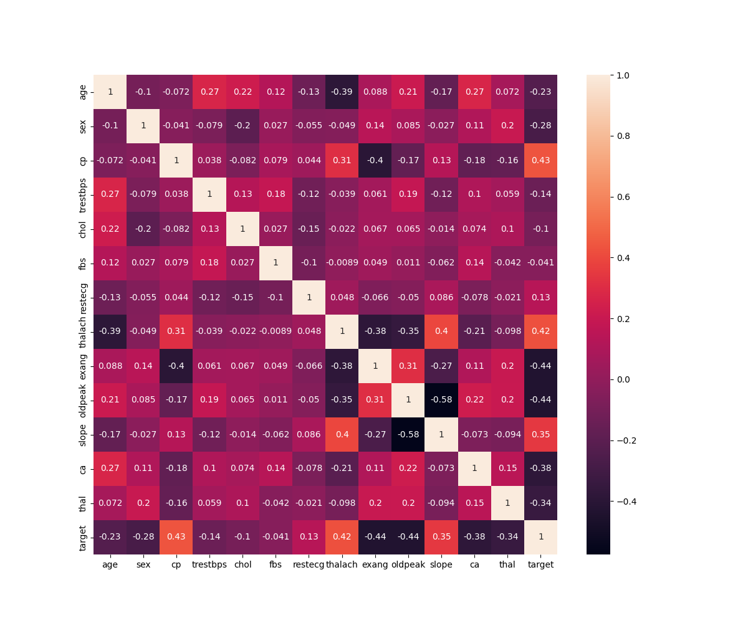

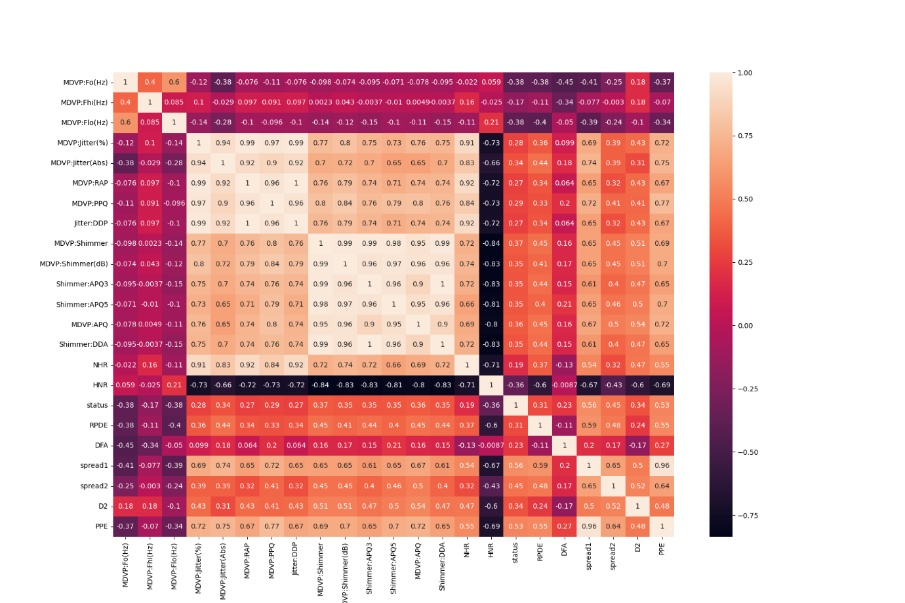

In comparison to traditional diagnostic tools and healthcare applications, our Smart Diagnose Hub stands out in several key areas. Firstly, our machine learning models undergo rigorous preprocessing of data, ensuring optimal accuracy in predicting multiple diseases based on user inputs. Through continual refinement and selection of the best-performing models, we have achieved superior predictive capabilities, providing users with reliable and timely insights into their health status.

1. **Applicable Patents**

In developing Smart Diagnose Hub application, it had meticulously evaluated the technological components and frameworks utilized, considering potential patentable aspects within our solution. While we have not applied for patents ourselves, we acknowledge the significance of existing patents that may be relevant to our project. Here are some examples of applicable patents related to the technology, software, and frameworks incorporated into our product/service idea:

**6.1 Machine Learning Algorithms:**

We utilize various machine learning algorithms for disease prediction and analysis. Patents related to specific algorithms or techniques, such as deep learning architectures, ensemble methods, or feature selection algorithms, may be relevant.

**6.2 Data Preprocessing Techniques:**

Our application employs advanced data preprocessing techniques to clean and prepare datasets for machine learning model training. Patents related to data cleaning, normalization, or feature engineering methods could be applicable.

**6.3 Notification Systems:** The notification system integrated into our application to send monthly updates and reminders to users may involve patented technologies related to push notification delivery, scheduling algorithms, or user engagement strategies.

**6.4 User Interface Design** The user interface design of our Smart Diagnose Hub plays a crucial role in providing an intuitive and seamless user experience. Patents related to graphical user interfaces (GUIs), interactive design elements, or gesture-based interactions may be relevant.

**6.5 Health Data Privacy and Security** Given the sensitive nature of health data handled by our application, patents related to data encryption, secure communication protocols, or privacy-preserving techniques could be pertinent to ensuring compliance and safeguarding user information.

**6.6 Predictive Analytics Models**: Beyond disease prediction, our application offers advanced analytics and insights into health trends and patterns. Patents related to predictive analytics algorithms, time-series analysis methods, or anomaly detection techniques may be relevant.

1. **Applicable Regulations**

In developing our Smart Diagnose Hub application, we are cognizant of the regulatory landscape surrounding the utilization of machine learning in healthcare. Compliance with applicable regulations is paramount to ensure the ethical and legal use of our technology while safeguarding user privacy and data security.

1. General Data Protection Regulation and the Health Insurance Portability and Accountability to safeguard user privacy and protect sensitive health data.
2. Ethical Guidelines for AI in Healthcare.
3. Fairness, Accountability, and Transparency in Machine Learning.
4. **Applicable Constraints:**

* Hardware and Software Compatibility**.**
* Data Quality and Availability.
* User Adoption and Trust.
* Regulatory Compliance Costs.
* Scalability and Maintenance.

1. **Business Opportunity**

For our Smart Diagnose Hub application, we propose a business model centered around providing value-added services while ensuring accessibility and affordability for users. Here's a detailed outline of our monetization strategy:

* + **Freemium Model**: The core functionalities of our Smart Diagnose Hub, including disease prediction, personalized solutions, and basic data analysis, will be offered for free to all users. This allows for widespread adoption and ensures that essential healthcare services are accessible to everyone.
  + **In-App Purchases:** We may offer in-app purchases for specific add-on features or premium content, such as specialized disease prediction models for rare conditions, exclusive educational resources, or advanced data visualization tools. This allows users to customize their experience and access additional functionalities as needed.

**9.3 Partnerships and Collaborations**: Collaborating with healthcare providers, insurance companies, pharmaceutical companies, and research institutions presents opportunities for revenue generation.

**9.4 Advertising Revenue:** While maintaining a user-friendly and non-intrusive experience, we may incorporate targeted advertising into our platform to generate additional revenue.

**9.5 Data Monetization:** Aggregated and anonymized user data can be leveraged for insights generation, market research, and healthcare analytics. By offering data analytics services to third-party organizations, we can generate revenue while respecting user privacy and maintaining data security.

**9.6 Corporate Wellness Programs**: Offering our Smart Diagnose Hub as part of corporate wellness programs presents an opportunity to monetize our platform while promoting employee health and well-being. Employers can subscribe to our services to provide their workforce with access to personalized health assessments, disease prevention strategies, and wellness resources.

1. **Concept Generation**

Smart Diagnose Hub project involves ideating innovative approaches to enhance disease prediction, personalized health insights, and data analysis capabilities. Here are several classification techniques used for model selection. A well-trained model can either be repurposed or built. But building a model with the resources and data we have is dilatory but possible. The customer might want to spend the least amount of time giving input data. This accuracy will take a little effort to nail, because it is imprudent to rely purely on Classic Machine Learning algorithm.

After Preprocessing the data, we have used different classification models and the we finalize the model who gives good accuracy:

In Diabetes we have used: Logistic Regression, Decision Tree, Random Forest, Naïve Bayes.

In Heart Disease we have used: Logistic Regression, Decision Tree, Random Forest, Naïve Bayes, SVM. (Used K-fold Cross Validation Technique)

In Parkinsons Disease we have used: Logistic Regression, Decision Tree, Random Forest, Naïve Bayes, SVM.

Diabetes: 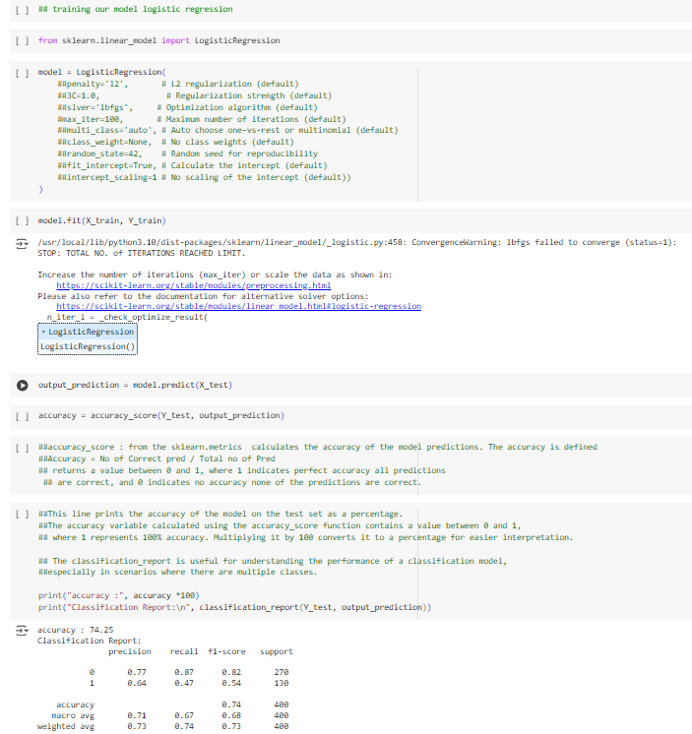

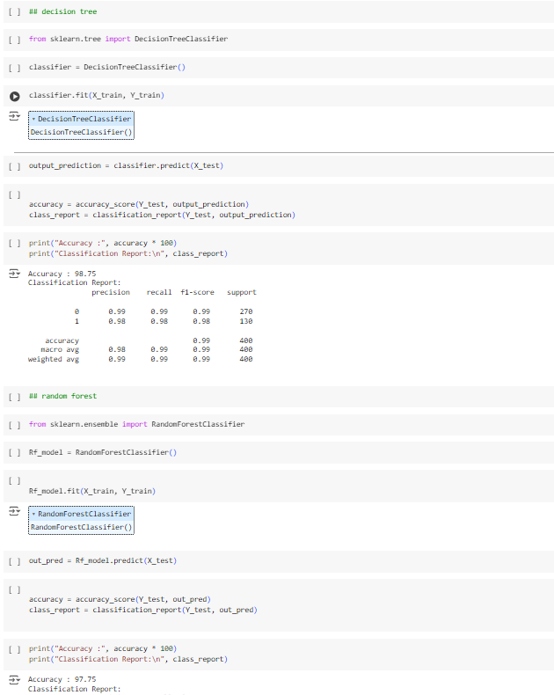

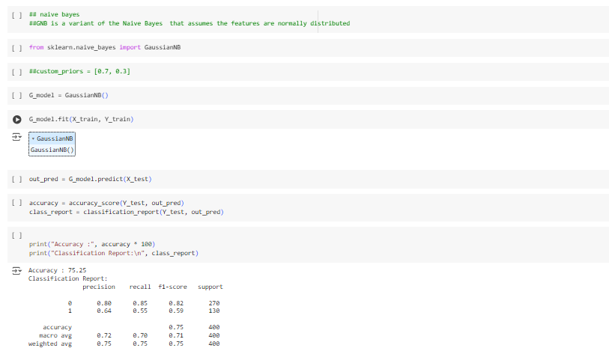

Heart Disease: 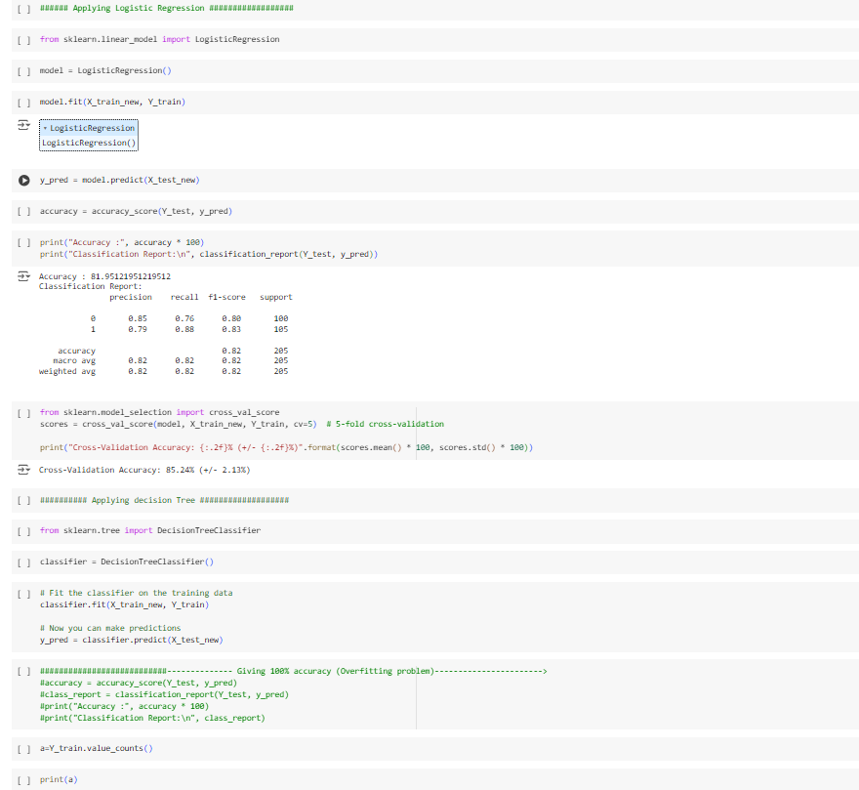

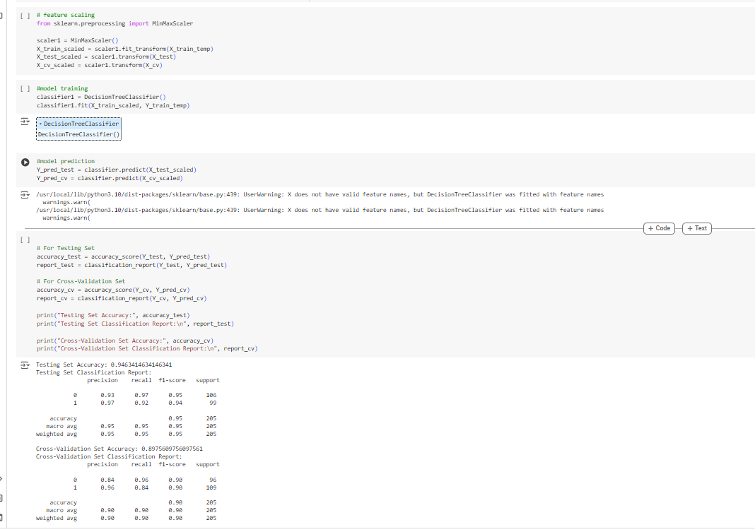

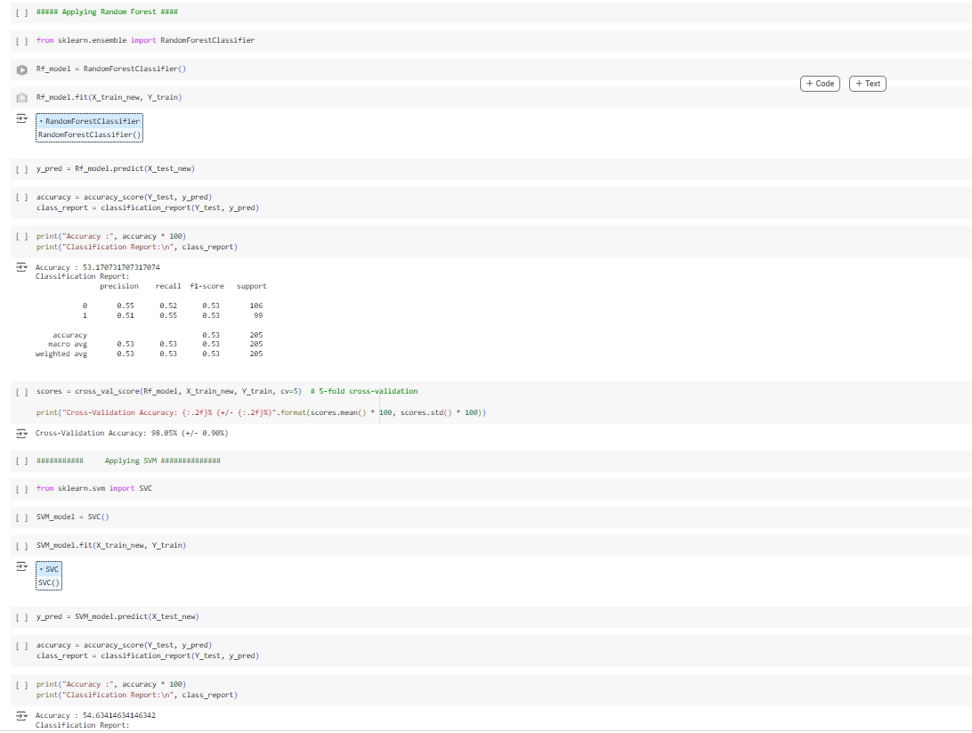

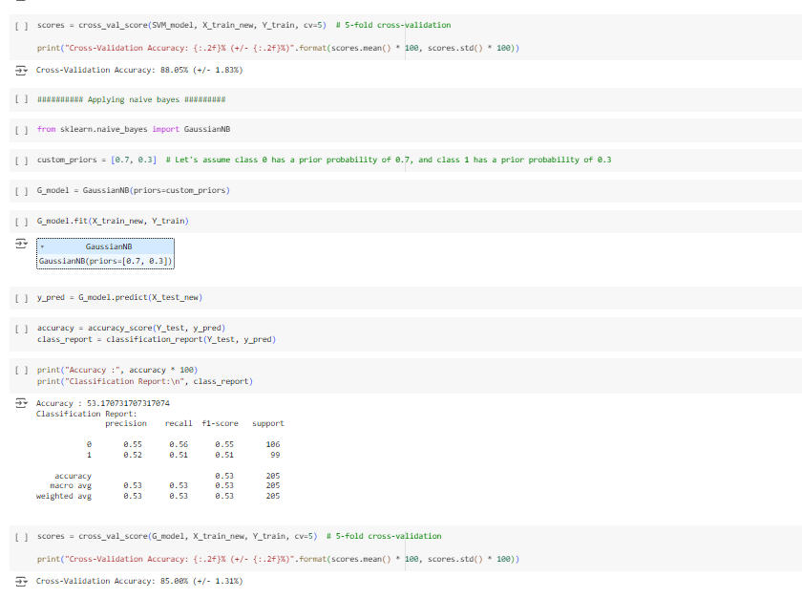

Parkinsons Disease: 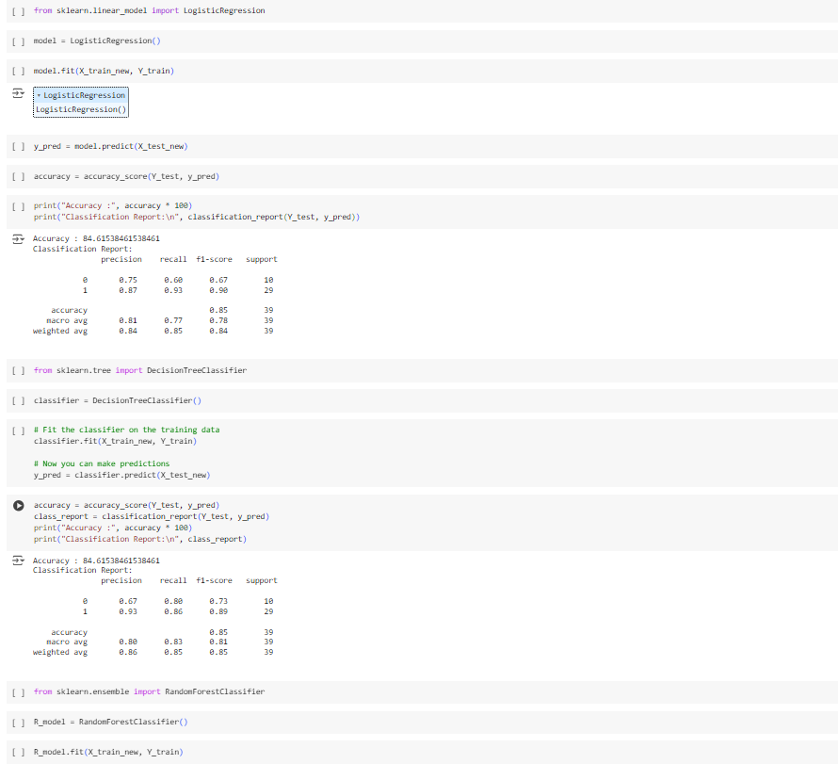

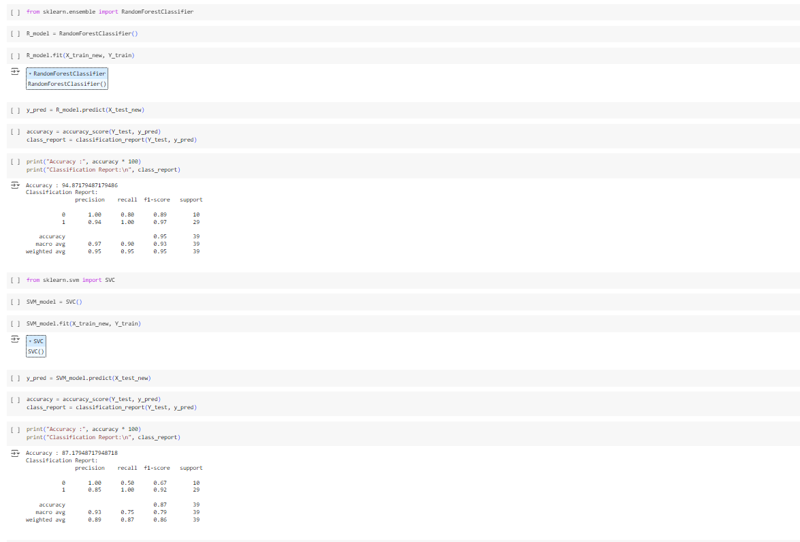

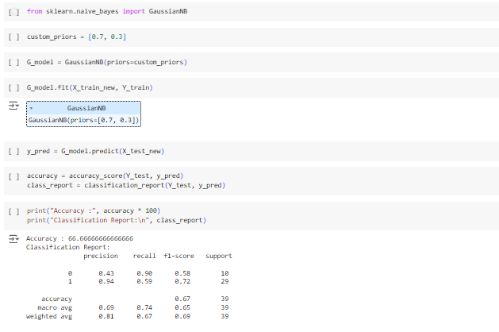

1. **Concept Development**

Concept development of models for our Smart Diagnose Hub involves designing and refining machine learning algorithms to accurately predict diseases, provide personalized health insights, and analyse health data effectively.

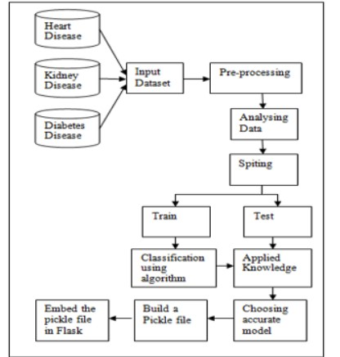

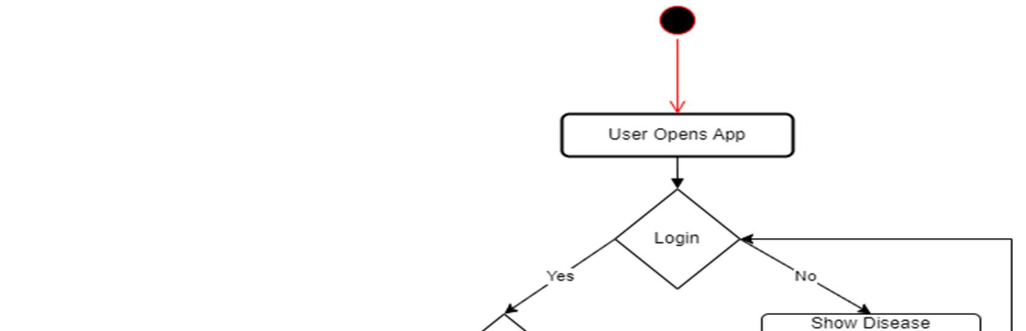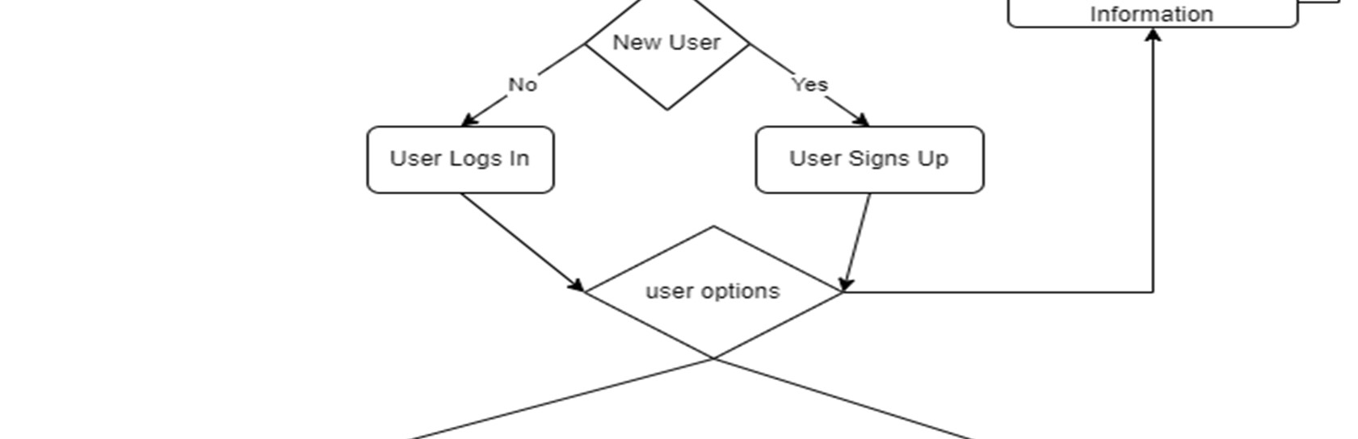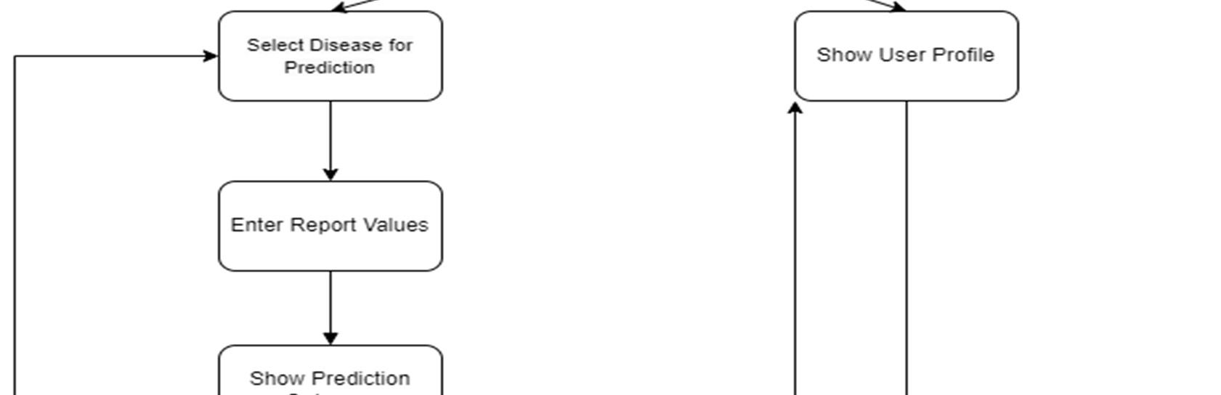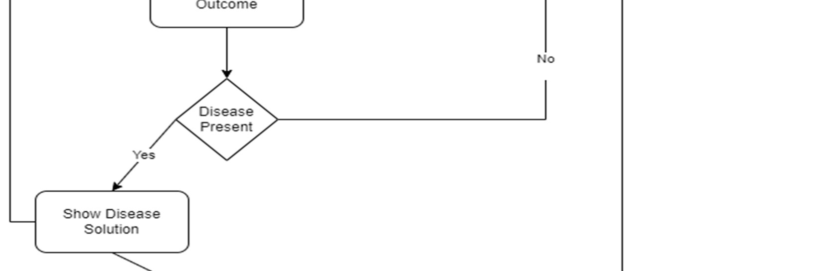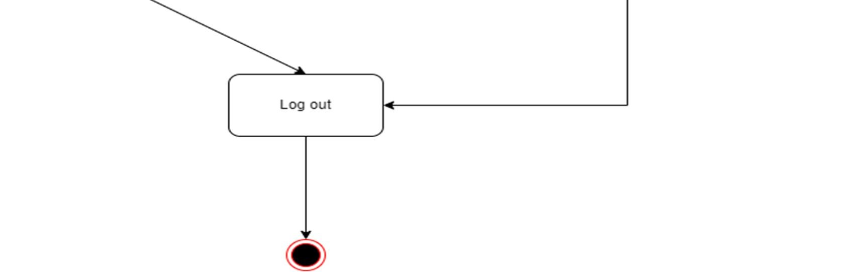

1. **Final Product Prototype:**

The Smart Diagnose Hub is an innovative digital healthcare solution leveraging machine learning and artificial intelligence to revolutionize disease prediction, personalized health insights, and data analysis. This prototype represents a cutting-edge platform that empowers users to proactively monitor their health, receive accurate disease predictions, and access personalized recommendations for improved well-being. By integrating advanced machine learning models with intuitive user interfaces and robust data analytics capabilities, the Smart Diagnose Hub offers a comprehensive and user-centric approach to healthcare management. Through continuous refinement and iteration, this prototype aims to address the evolving needs of users in an ever-changing healthcare landscape, fostering a healthier and more informed society.

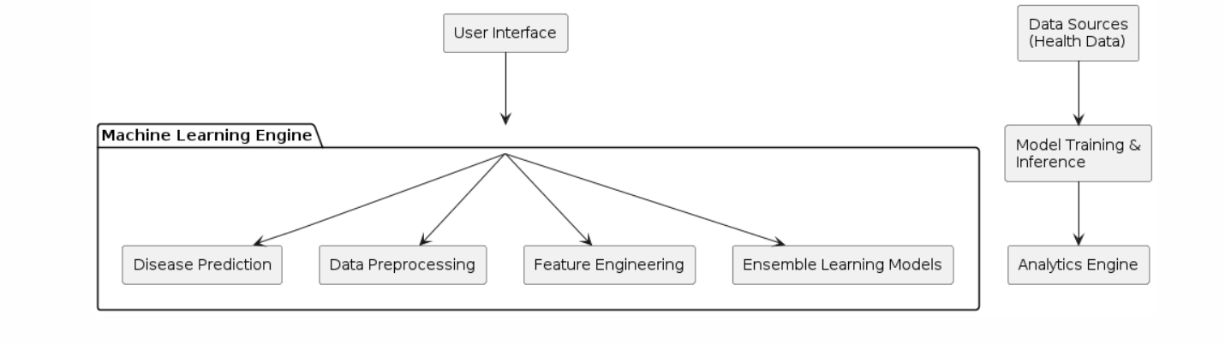

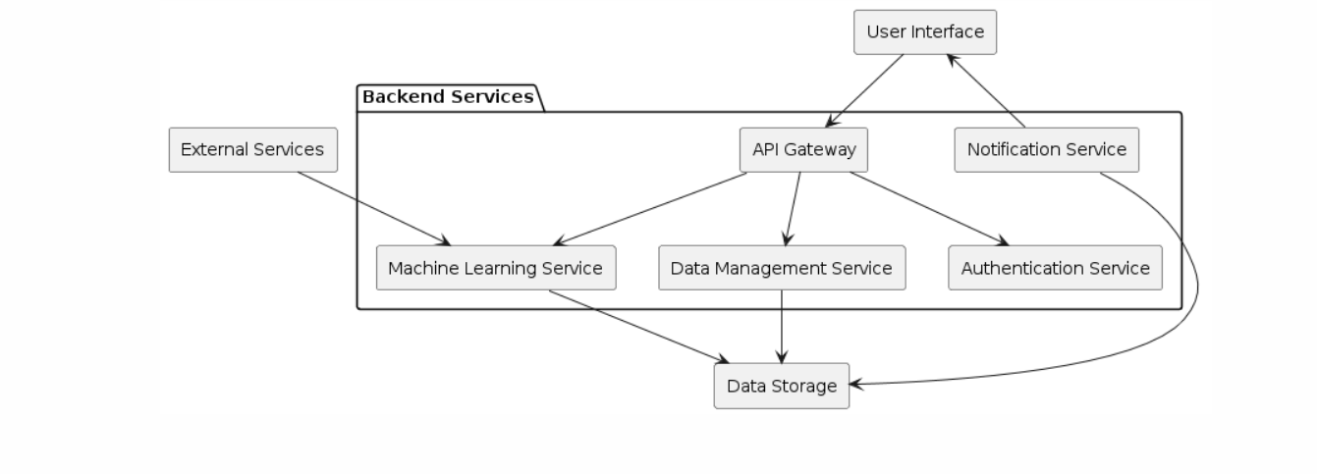

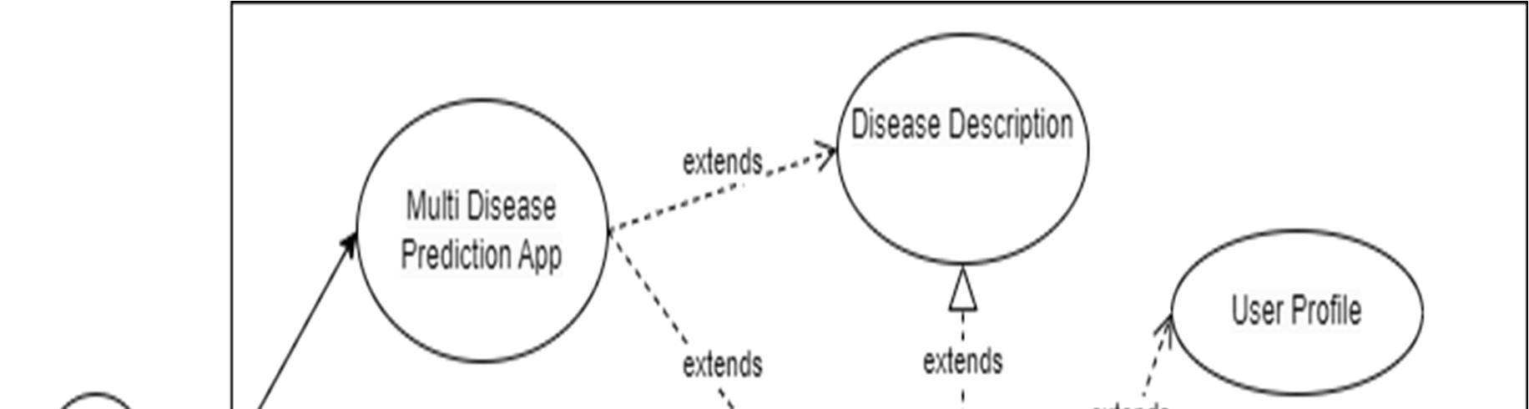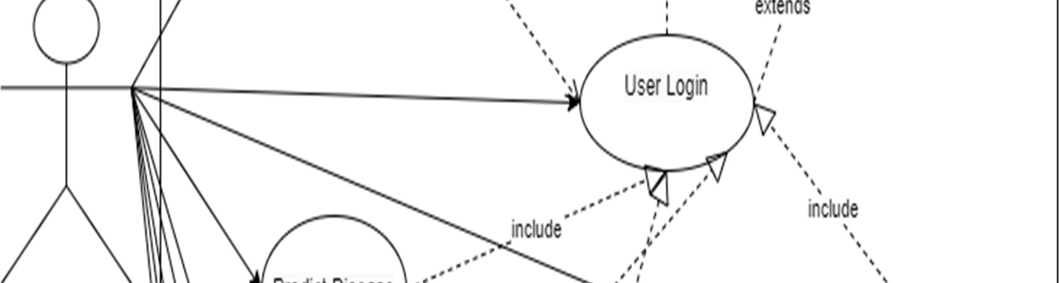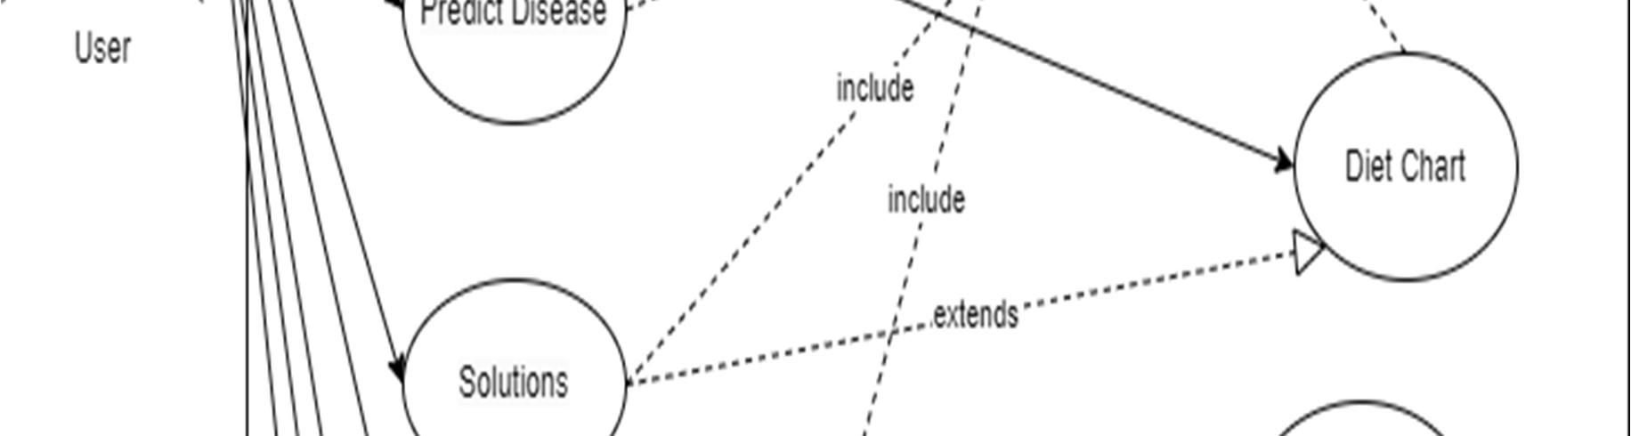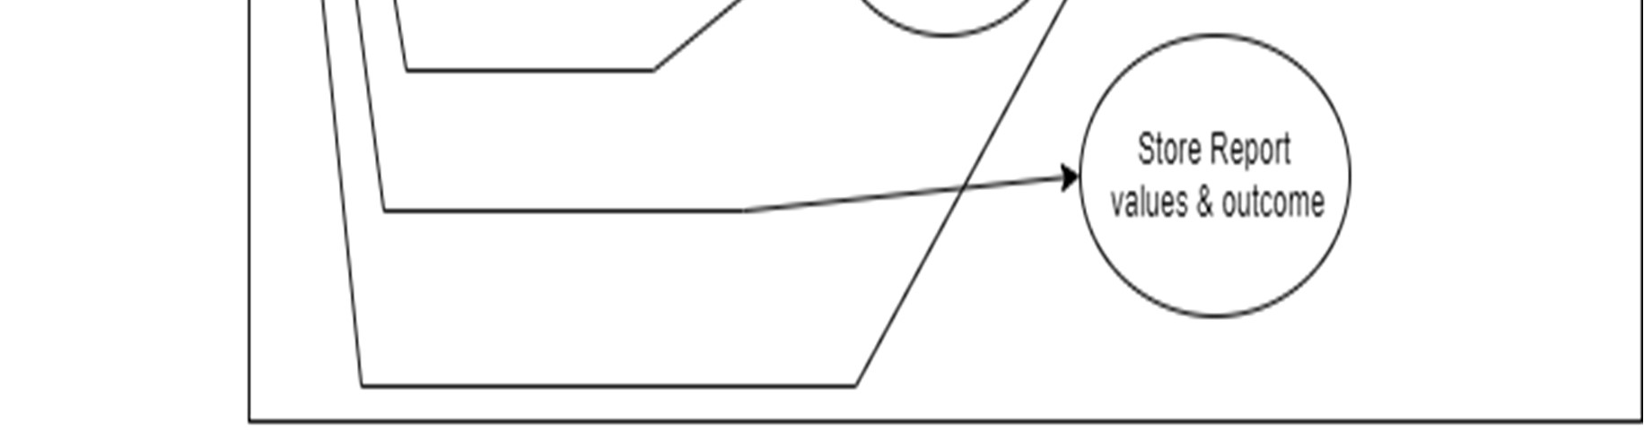

1. **Product Details:**

**SMART DAIGNOSE HUB (APP):**

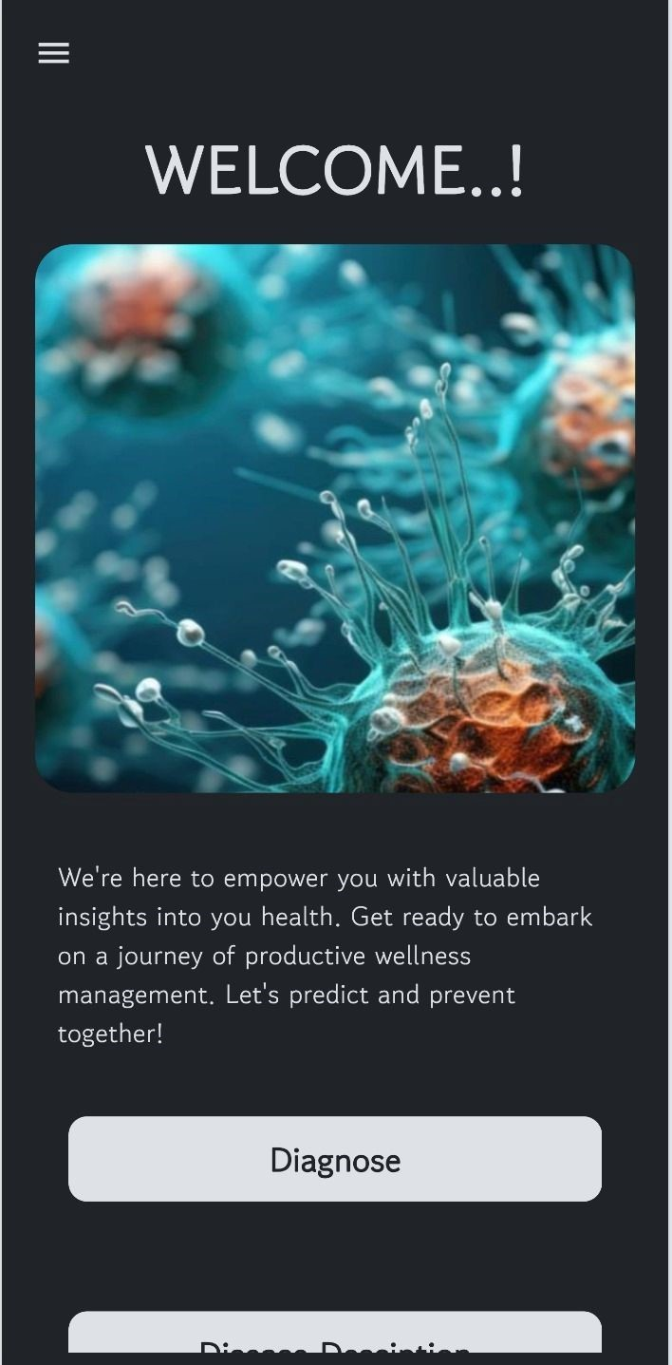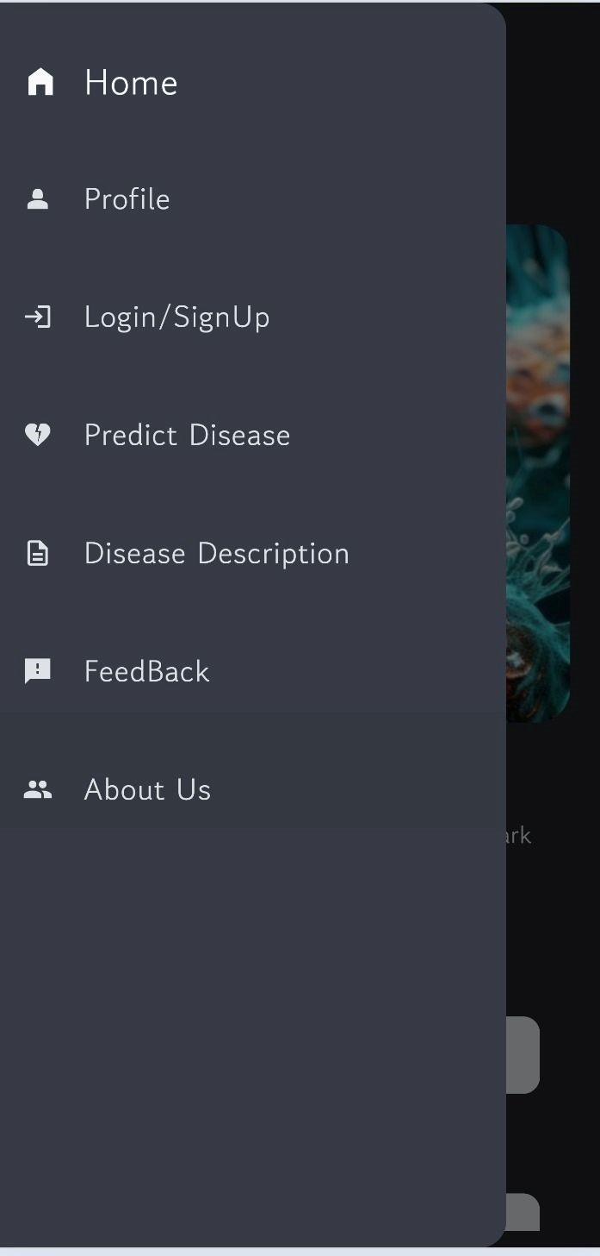

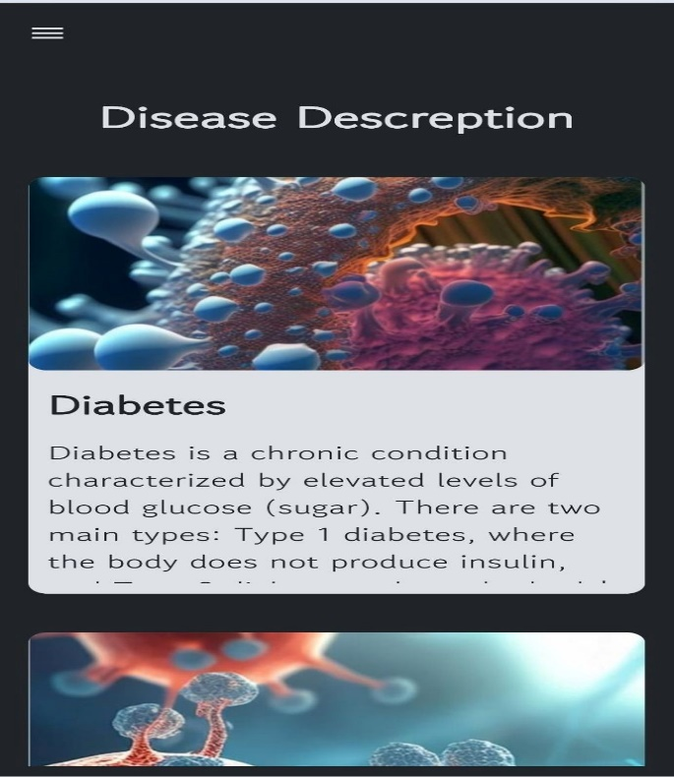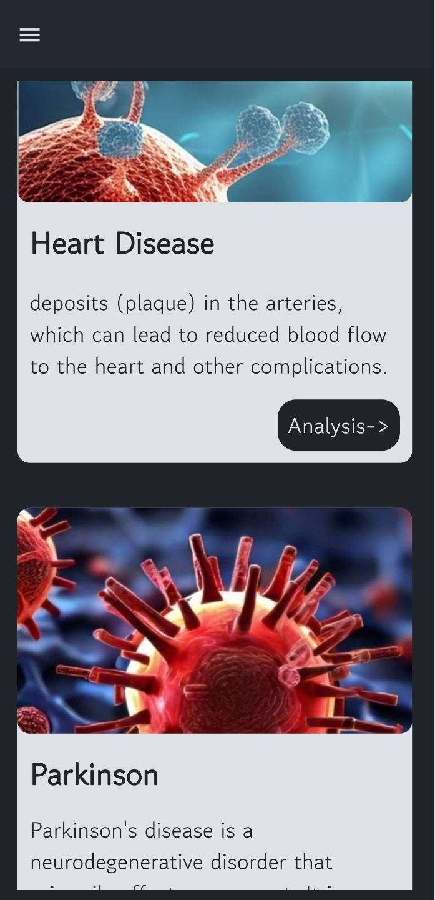

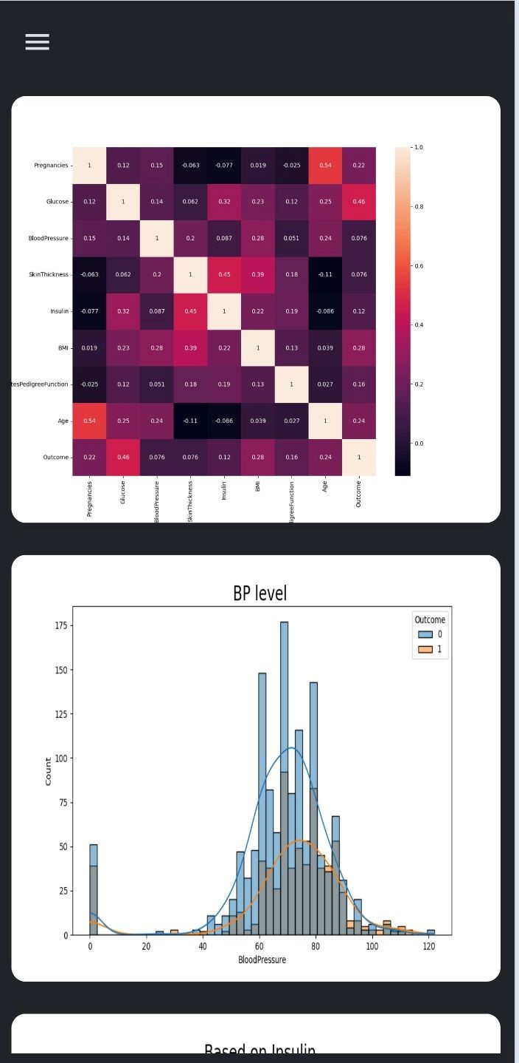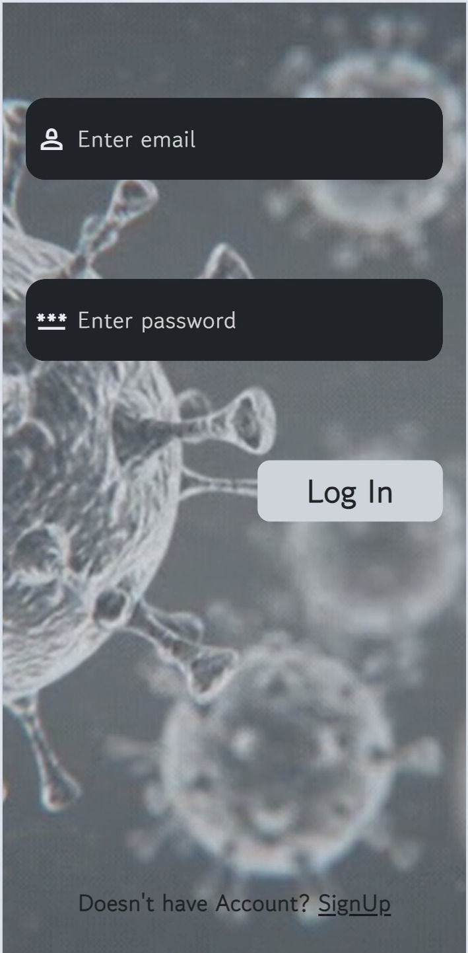

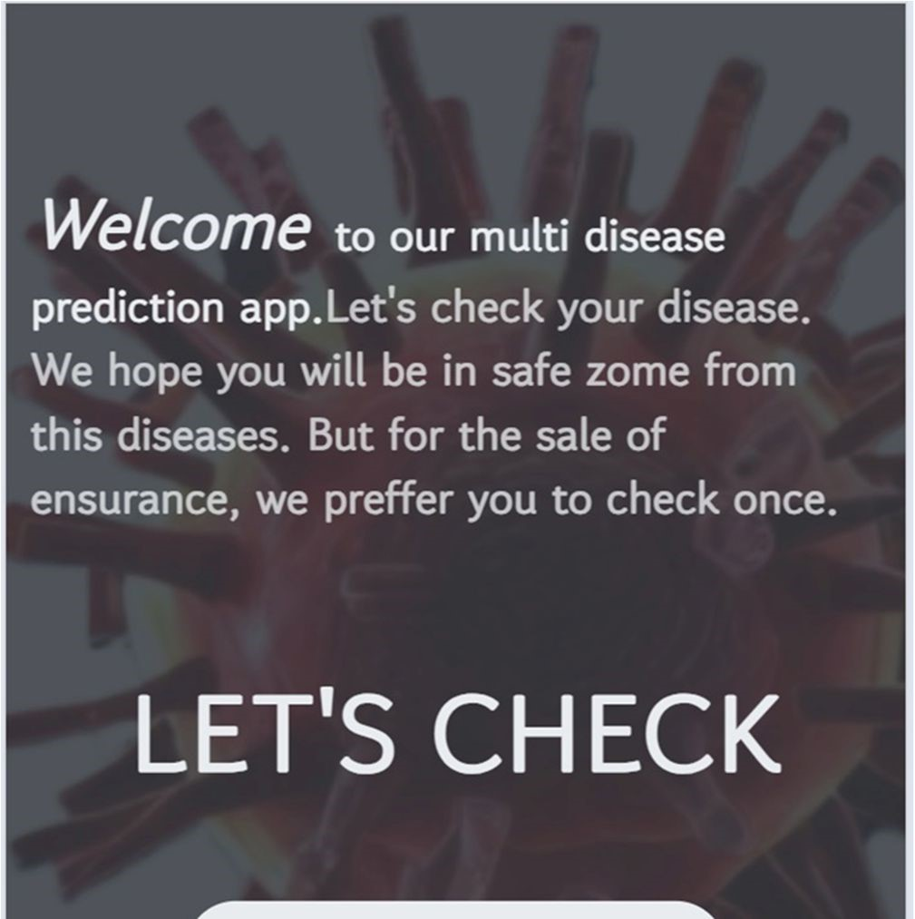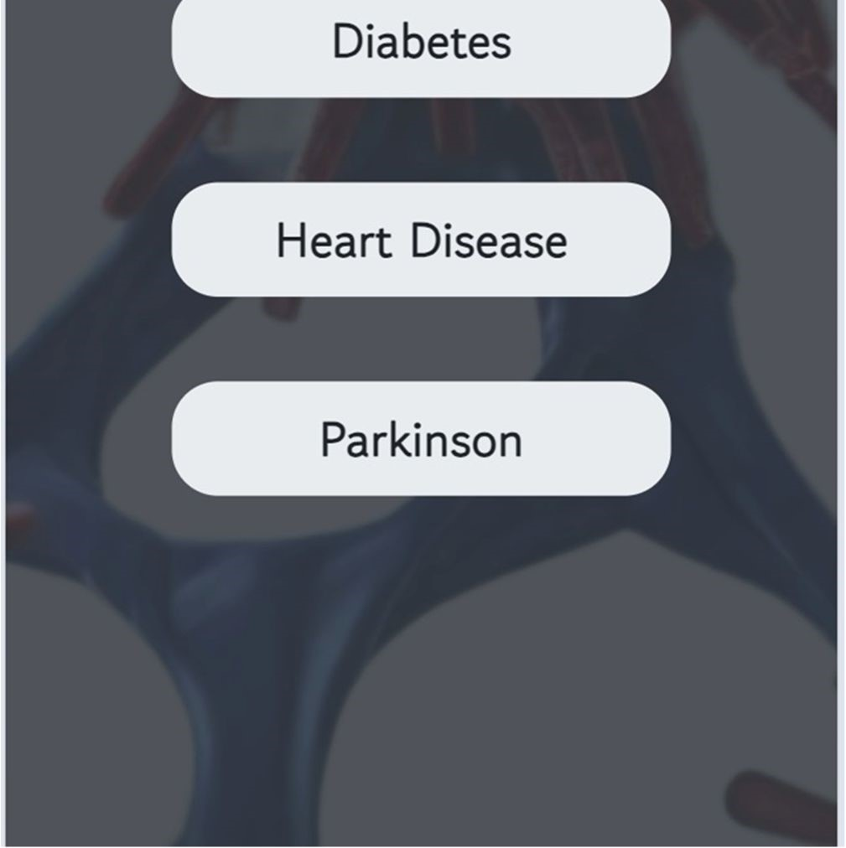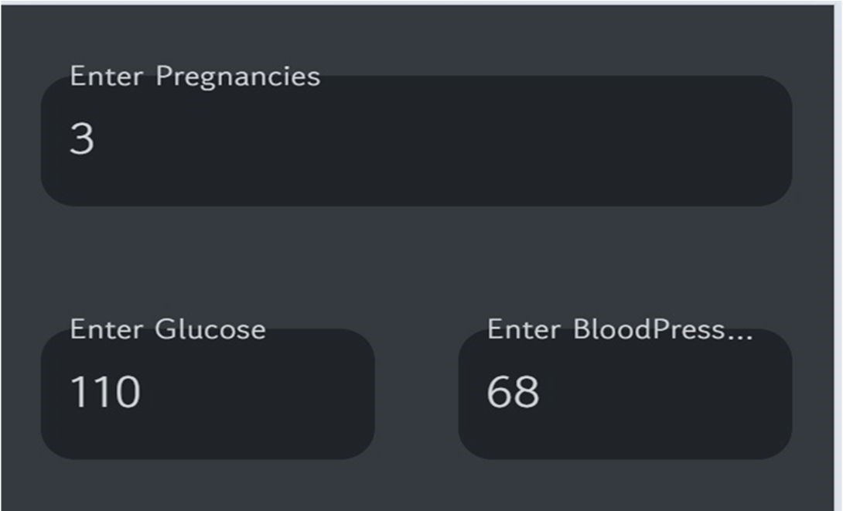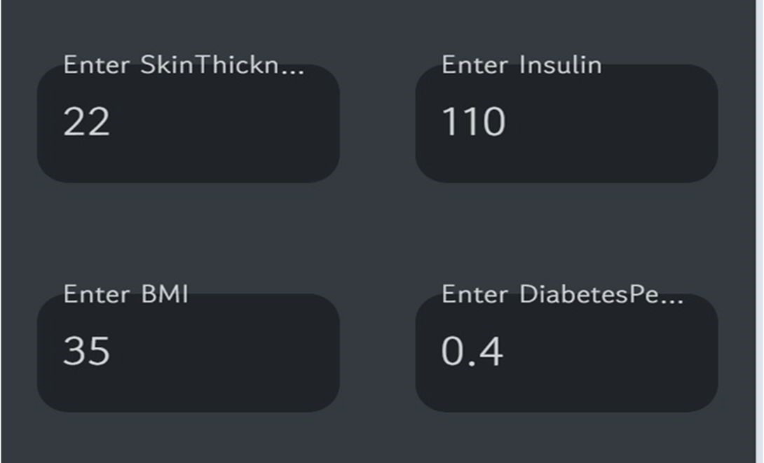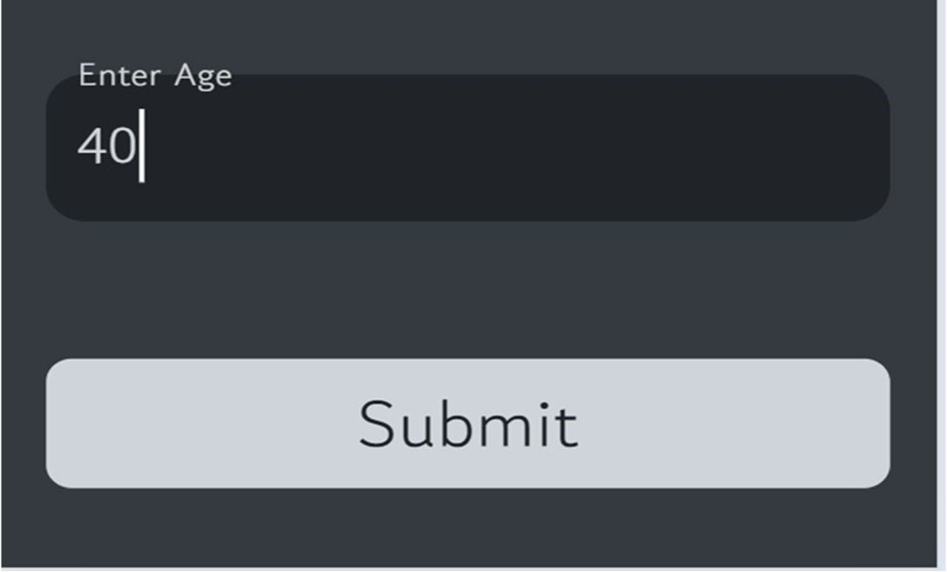

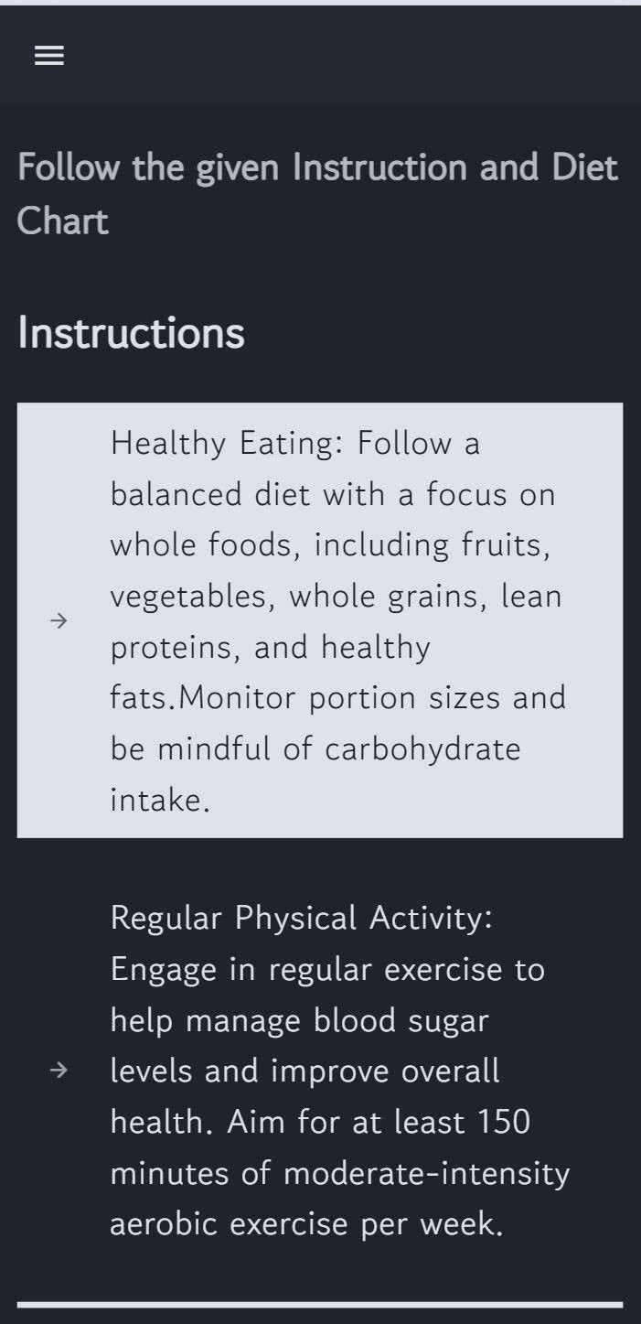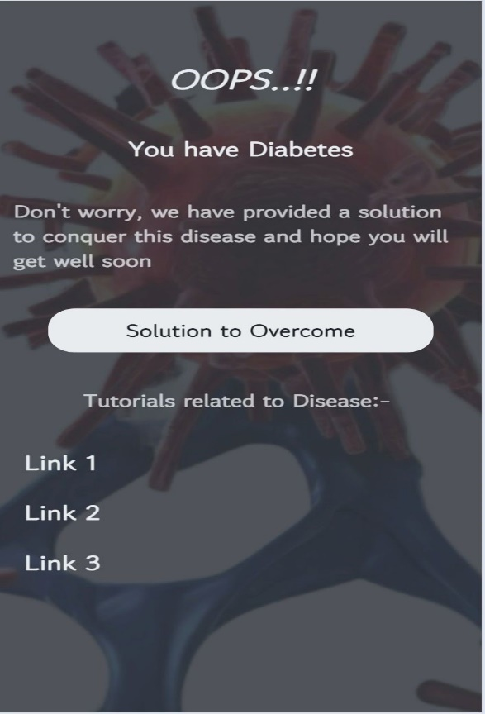

**Machine Learning Models with scikit-learn**: Python libraries such as scikit-learn will be leveraged for developing machine learning models for disease prediction. Scikit-learn offers a comprehensive suite of algorithms and tools Introduction for data preprocessing, model training, and evaluation, facilitating the development of accurate and reliable predictive models.

* Multiple Disease Prediction: Input specific symptoms and receive accurate predictions for a wide range of diseases, enabling early detection and intervention.
* Personalized Solutions: Access tailored recommendations and treatment options based on individual health profiles and medical history.
* Comprehensive Analysis: Explore detailed insights into disease trends, demographic factors, and regional variations for a deeper understanding of health conditions.
* Monthly Notifications: Stay informed about health updates, preventive measures, and wellness tips with monthly notifications and reminders.
* User History Tracking: Maintain a comprehensive record of past diagnoses, treatments, and health assessments for continuity of care and monitoring of health progress.

1. **Code Implementation:**

GitHub Link: https://github.com/BhavyaParekh/SmartDiagnoseHub_FinalProject

1. **Business Modelling**

A subscription business model is a recurring revenue model in which customers pay a weekly, monthly, or yearly fee in exchange for your products or services. Customers can renew their subscription after a certain period of time. This model allows you to leverage your customer relationships to create a steady stream of income.

In this Project we will be using subscription-based business model for a successful business development. Here we will provide customer some premium feature apart from prediction. There will be a section of graph which will provide easy insights of the previous results and reports. Will also add some wearable gadget compatible features for better results. The basic feature such as predicting the type of disease based on the report will be free for the users across all the platforms.

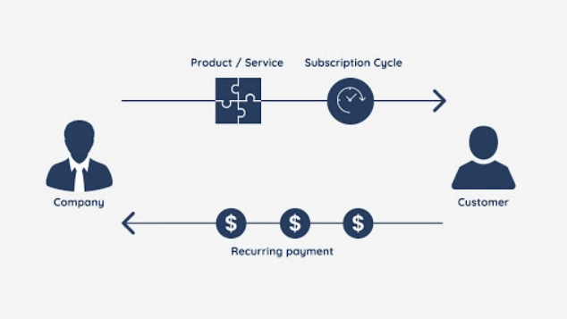

1. **Financial Modelling**

The financial equation provided aims to quantify the cost savings achieved through the use of a disease prediction app. This equation helps in evaluating the economic impact of early detection and management of chronic diseases such as diabetes, Parkinson's, and heart disease. The primary goal is to demonstrate how such predictive tools can lead to significant financial benefits by reducing treatment costs and increasing productivity.

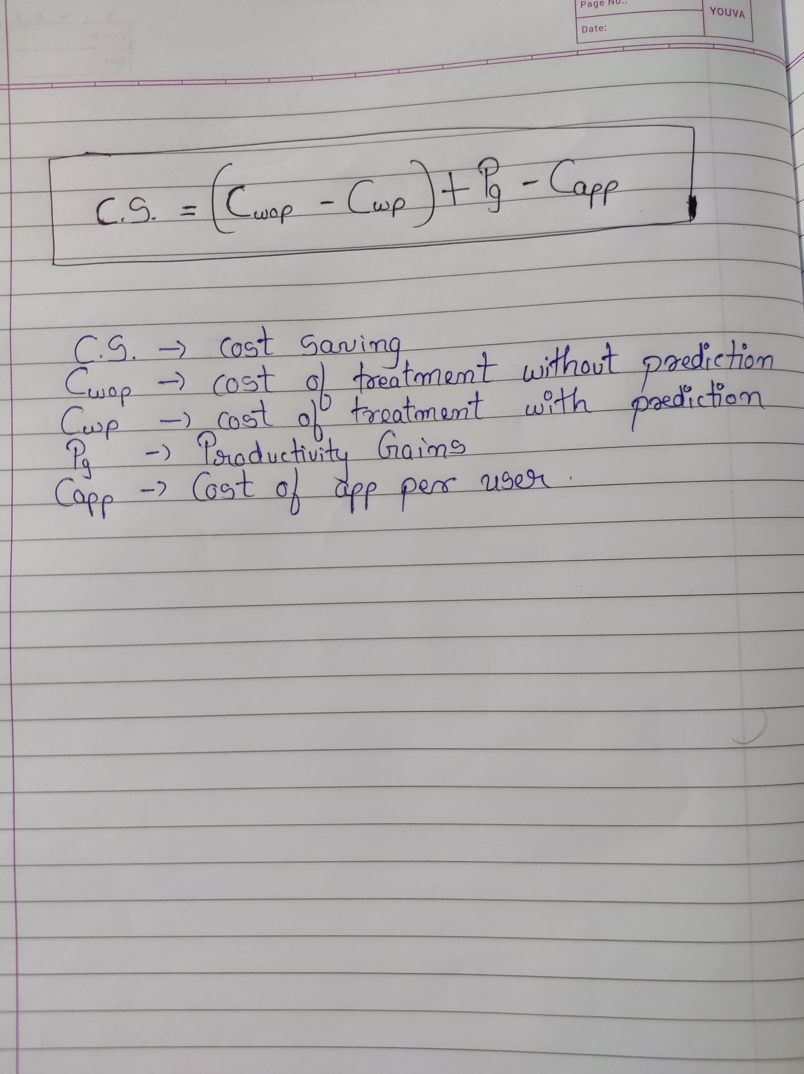

1. **Conclusion:**

In conclusion, the development of the Smart Diagnose Hub represents a significant advancement in the realm of digital healthcare solutions. Through the integration of state-of-the-art machine learning algorithms, intuitive user interfaces, and robust data analytics capabilities, our app offers a transformative approach to disease prediction, personalized health insights, and proactive health management. By harnessing the power of technology, we aim to empower users to take control of their health journey, make informed decisions, and lead healthier lives.